V = Vm[S]/Km+[S] --> Lineweaver-Burke --> 1/V = Km + [S]/Vm[S]

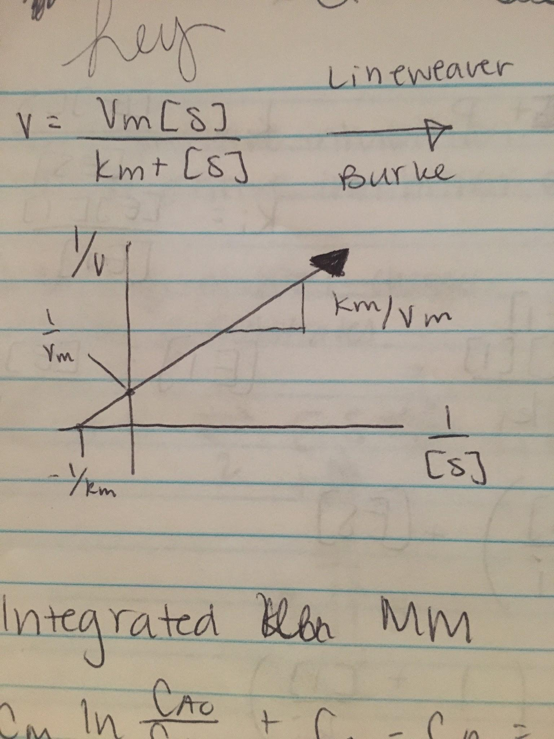

Need a lot of high substrate data.

**Integrated M&M**

Cmln(CA0/CA) + CA0 - CA = k3CE0t

Line form:

CA0 - CA / ln(CA0/CA) = -Cm + k3CE0t / ln(CA0/CA)

**Competitive Inhibition**

* Inhibitor and substrate compete for same active site
* Control activity and function of enzymes

EI <--> I + E + S <--> ES --> S + P

Km = [E][S]/[ES]

Ki = [E][I]/[EI]

[EI] = [E][I]/ki

[E0] = [E] + [ES] + [EI] = [E] + [ES] + [E][I]/ki = [E] * (1 + [I]/ki) + [ES]

[E0] - [ES] = [E] * (1 + [I]/ki)

[E] = [E0] - [ES] / (1 + [I]/ki)

Km = ([E0] - [ES]/1 + [I]/ki)[S] / [ES]

Km = ([E0] - [ES])[S] / [ES](1 + [I]/Ki)

Km (1 + [I]/ki) = ([E0]-[ES])[S]/[ES] = Km’

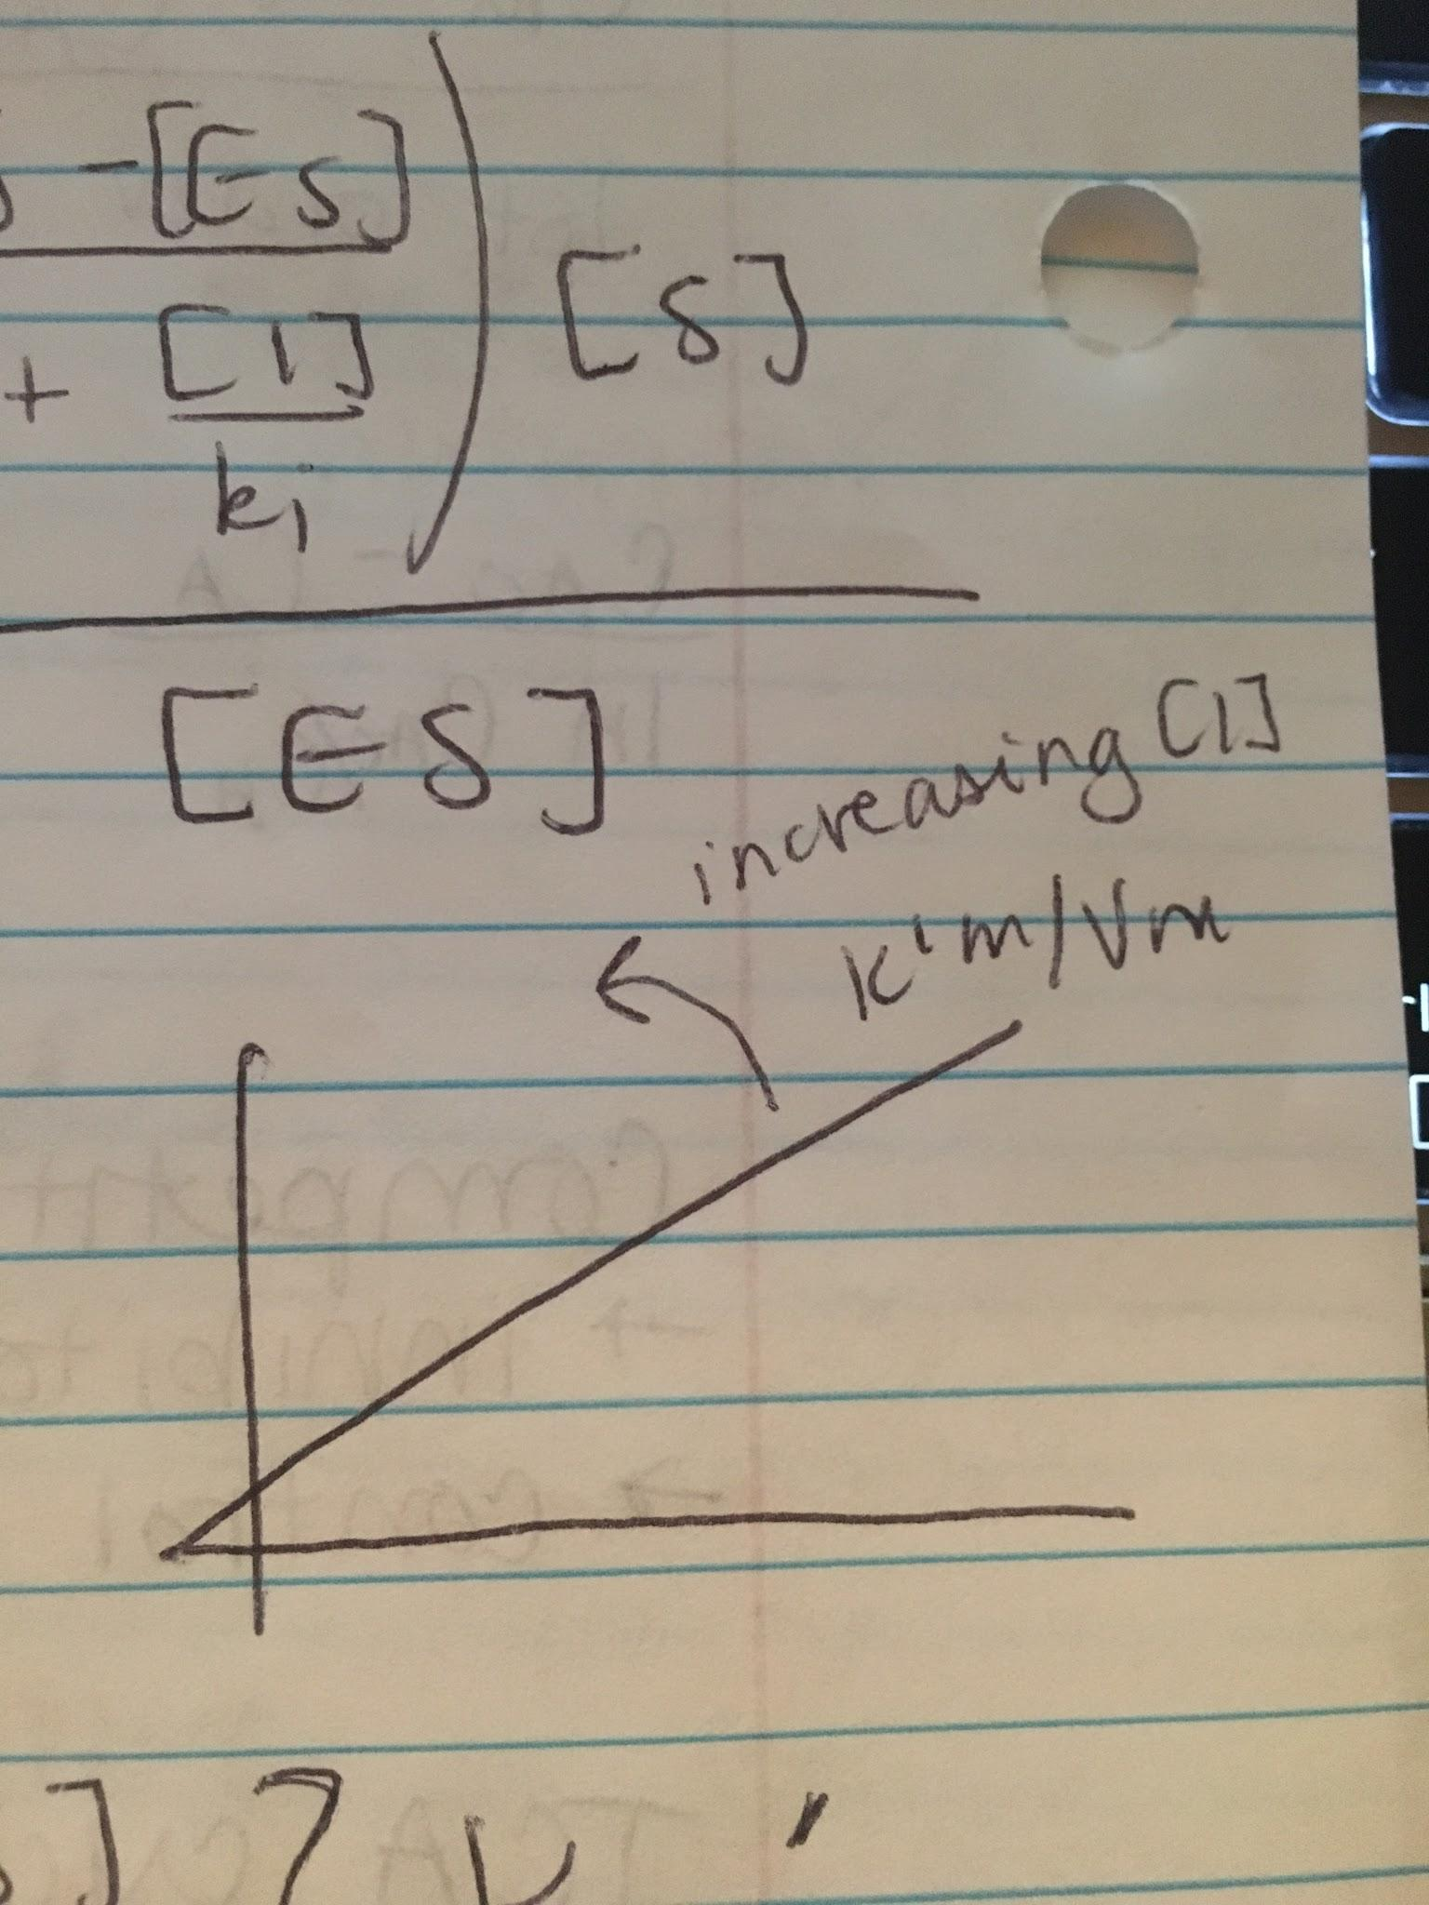

Lineweaver-Burke: 1/V = K’m/Vm * 1/[S] + 1/Vm (1/Vm does not change)